SECTION 1: Clone

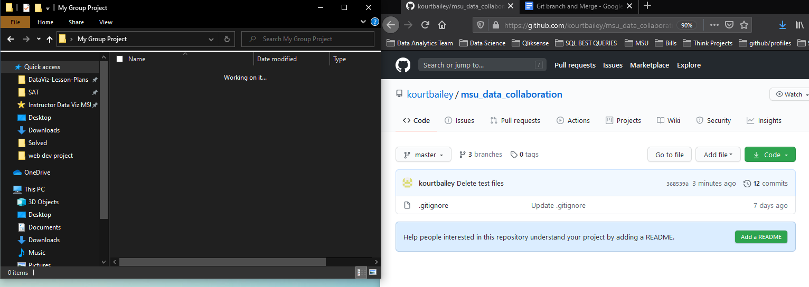

Git clone your repo using the git clone <name of your repo>.git

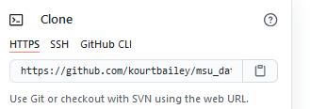

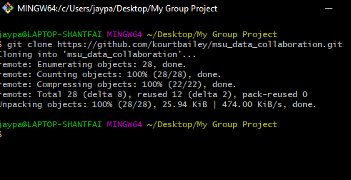

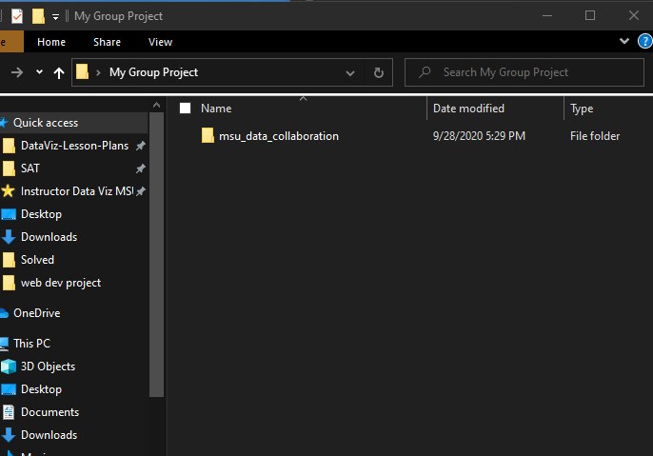

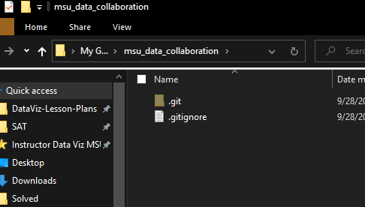

SECTION 2: Make your BRANCH

**WHY BRANCH?**

* When you are working on a team, you always want to ‘test’ a branch for review for **teammates,** then “**merge**” it to master for submission.
* Merging should be **without any** ‘conflicts’.

Instead of pushing your master - we want you to work on **branch** and then ‘collaboratively’ merge to **master.**

Git checkout -b <branchname>

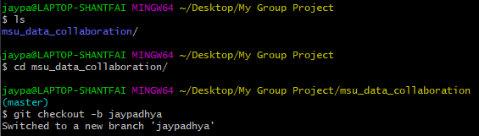

Now you shall see that git status is actually **“on branch”** and not **“on master”**

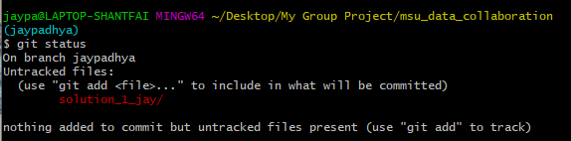

**Bring your solution folder to the same folder**

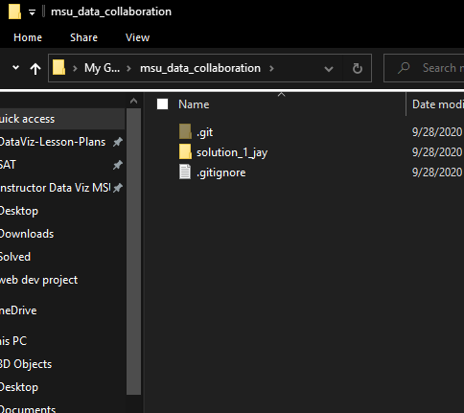

MAKE SURE YOU HAVE A SOLUTION ***FILE OF ANY TYPE*** INSIDE THIS FOLDER

**---- THIS SHOULD NOT BE EMPTY -----------------**

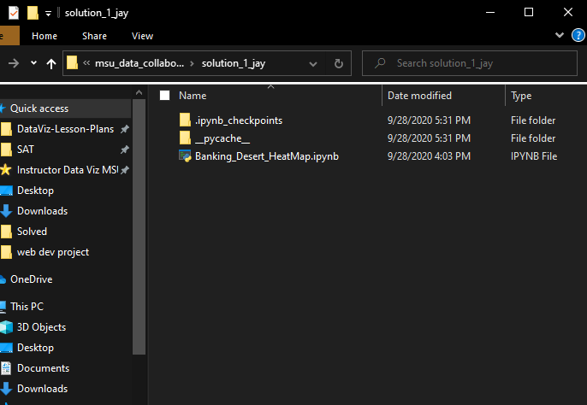

**Your usual**

Git add -A

Git commit -m “your solution”

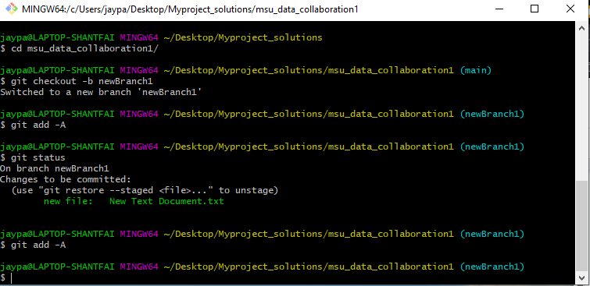

Git push origin <branchname>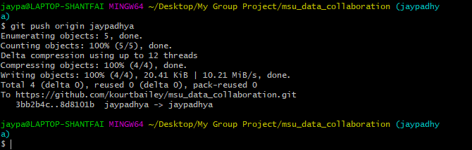

**CHECK YOUR GITHUB**

There should be changes in the number of **‘branches**’

Click on the ‘’ page to see your branches

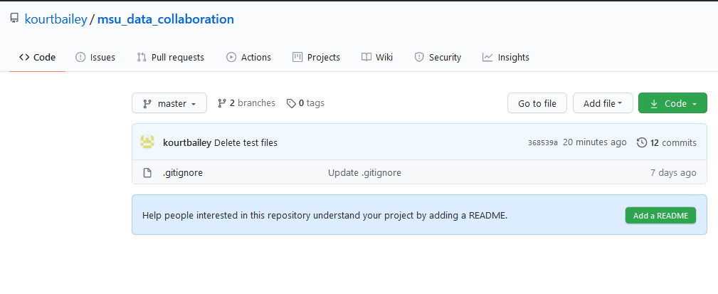

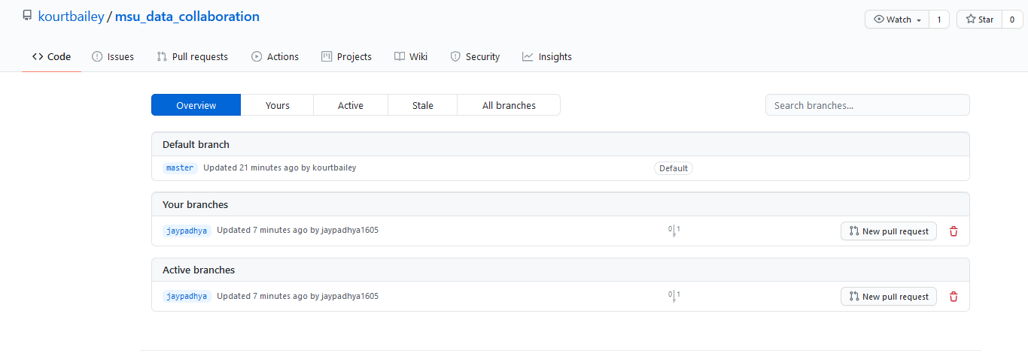

Now click on the “branch” name that you just made on Github 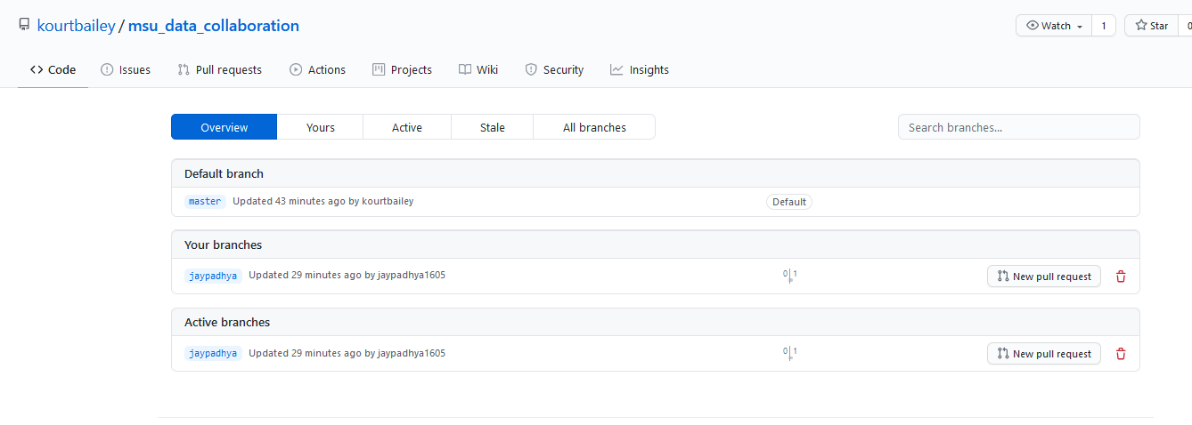

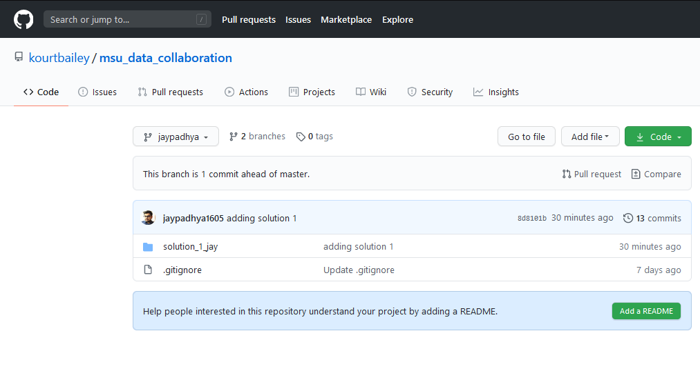

**Your Github page should have the same structure like your local for the branch.**

SECTION 3: Work on Your BRANCH

As you do your work, you will be doing multiple “**add**” “**commit**“ and “**push”** throughout your work. Note that you will spend the vast majority of your time in this phase. *These actions should be performed in the git-bash command line.*

SECTION 4: Merge

When you are done with working with the branch, you can finally merge your branch to the master as the final step. *The actions in this section are usually performed through the Web-based GUI.*

Section 4.1: Creating the Pull Request

Step 1 : You will see **“New Pull request”** on your branch

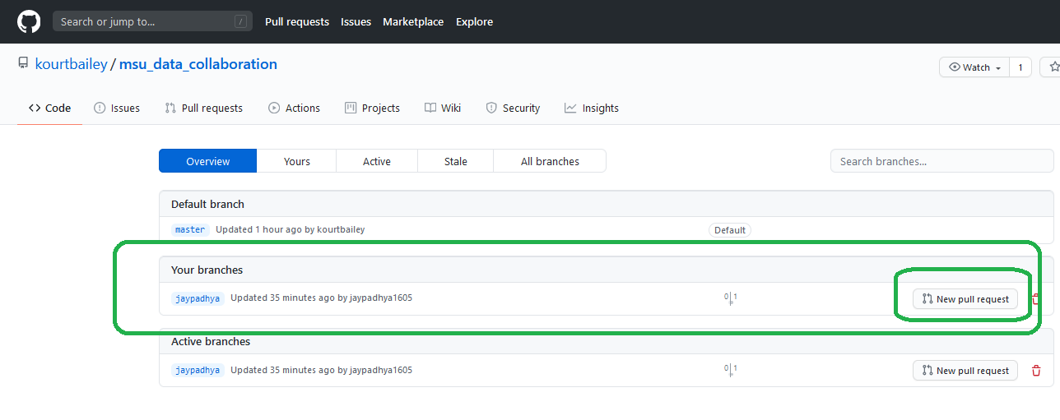

**New pull Request:**

* You will see ‘**Reviewers**’ on the top right

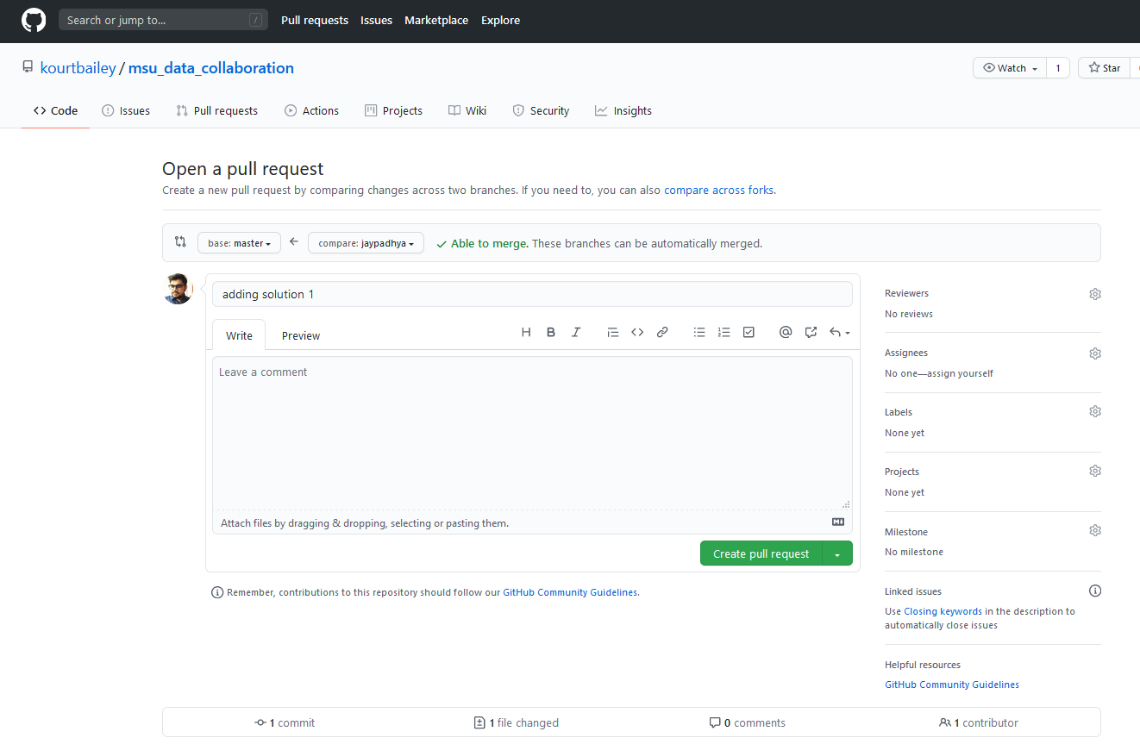

On clicking the **‘Reviewers**’ you will see your team members to review: add your teammates so they can review

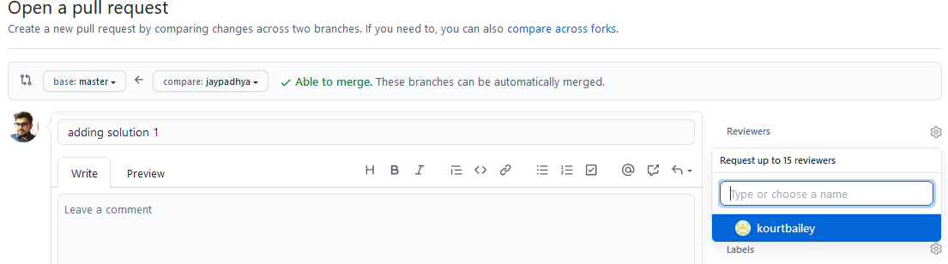

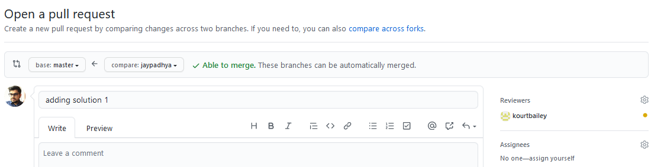

Once you have your reviewers, you should click a “**Create pull request**” 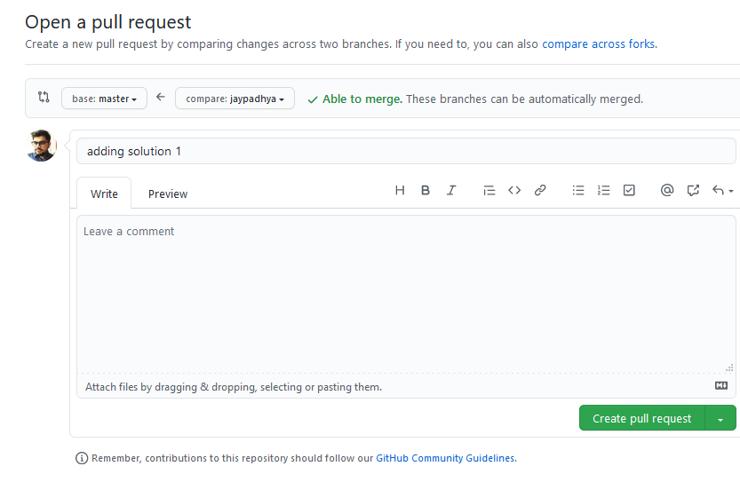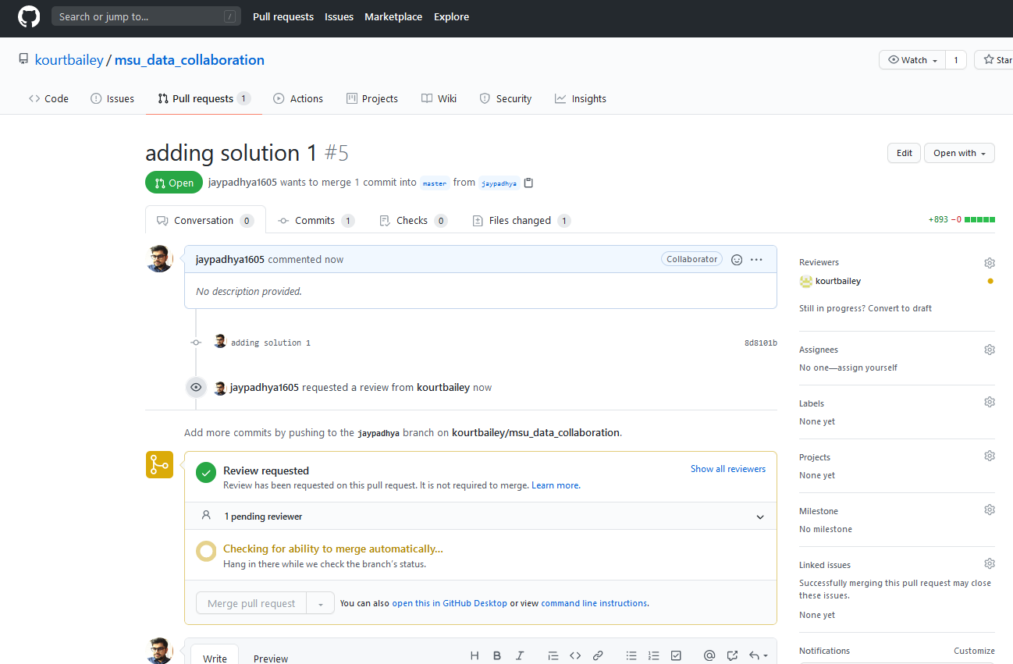

Section 4.2: Reviewing a Pull Request

This is the process that your teammate(s) will follow (and the process that you will follow to review theirs).

View the Pull Requests for your project; click on the Pull Request that is being considered

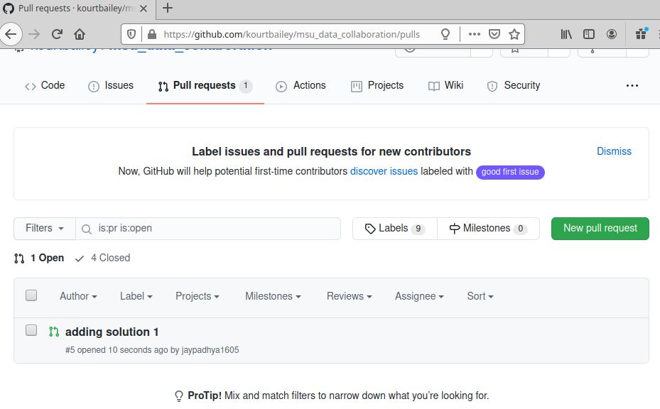

Click on the green “Add your review” box

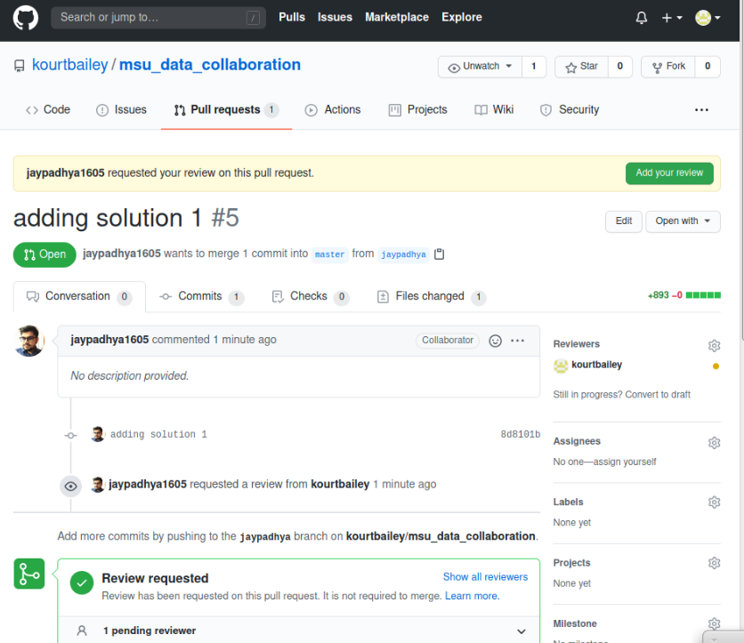

Review the code. Look at the changes. You can make comments on an individual line of code, and make a summary in the “Leave a Comment” box. You can select either “**Approve”** or **“Request changes”** to require changes before merging.

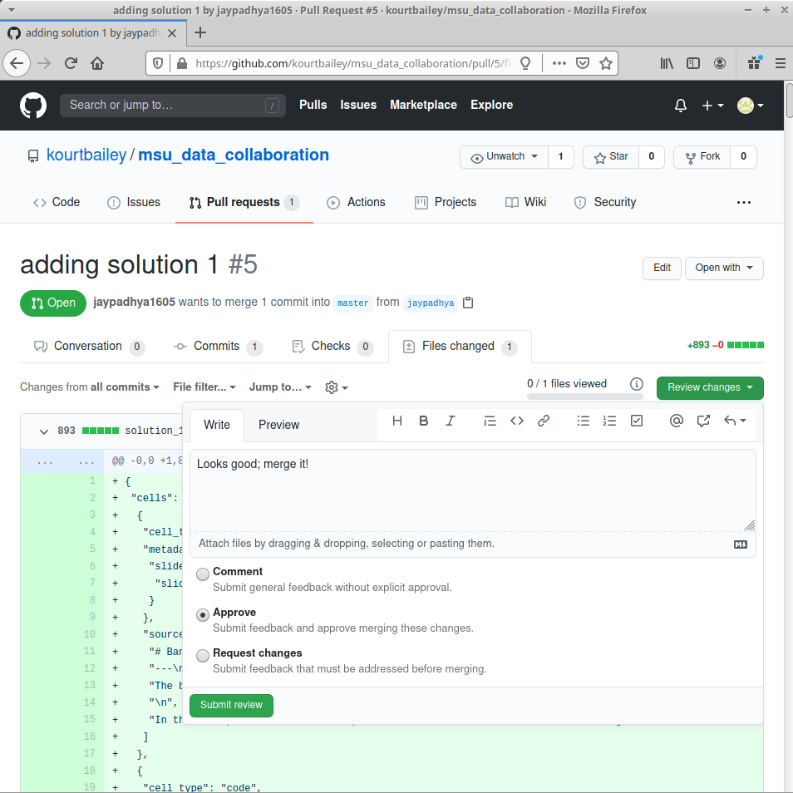

Section 4.3: Executing a merge request

* Check that your teammates have approved all of your requests.

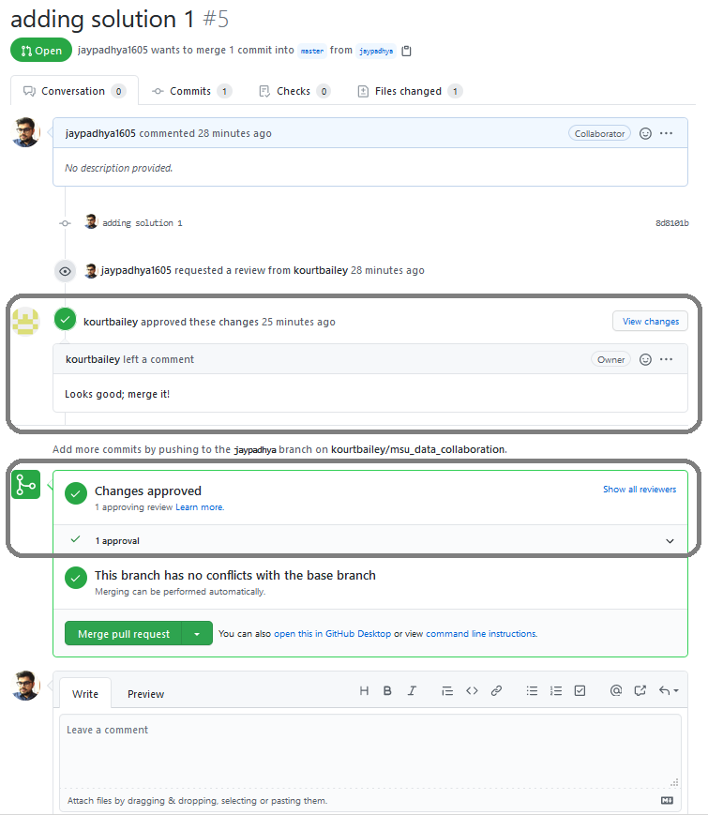

**Git merge using GUI**

* You will click “**Merge pull request”** to initiate merging the branch into master

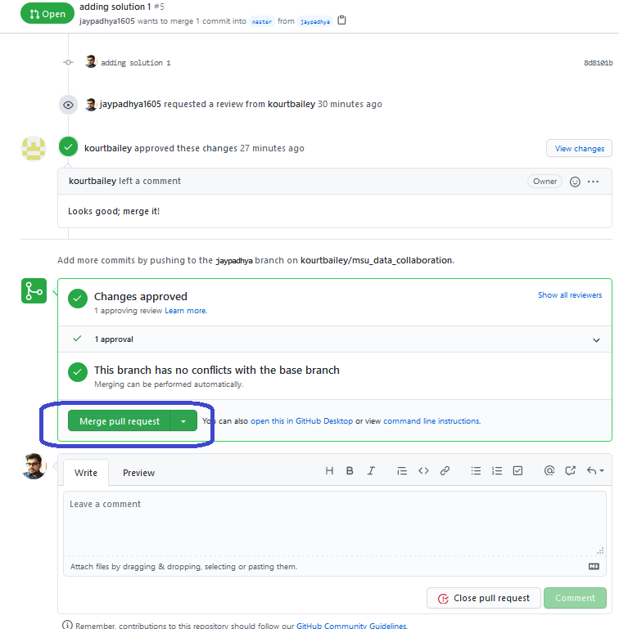

You will see that **‘request was successfully merge**’

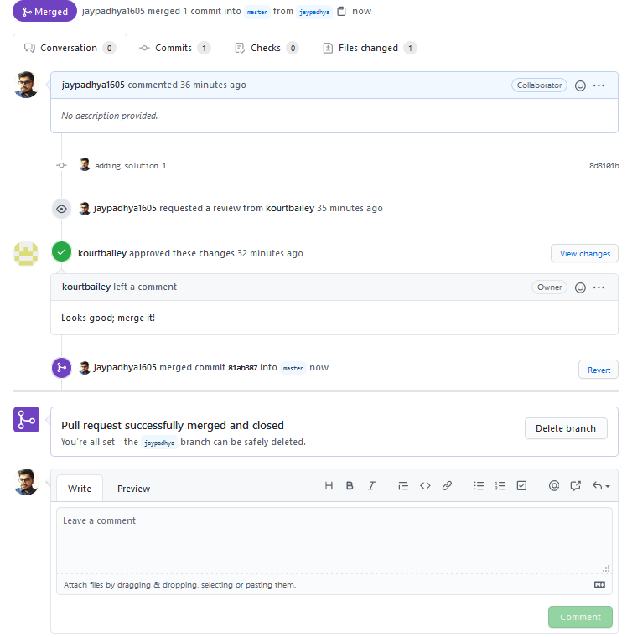

Github will prompt you to delete the branch if you have completed your job and don’t want to create unnecessary branches. You can always delete them later.

Your solution Folder should now be on Master

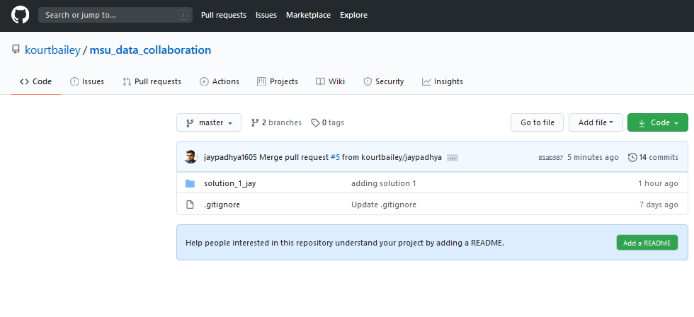

In order to delete your branch, you can simply go to branches again and delete them using with trash icon to extreme right of the branch 

